English in Malaysia:
The Low Performance of English literacy in rural areas
Quanying Du
Yue Christine Lee
Xiaohang Yu
Second Language Acquisition
Pennsylvania State University

Language policy
Malaysia, as a multiracial country, has a population with about 30 diverse ethnic groups. The largest population is Malays, which account for 50.4 per cent of the population. 23.7 per cent of the population are the descendants of Chinese, and the ones of Indian make up 7.1 per cent of the population. Therefore, the major languages used in Malaysia are Bahasa Malaysia, which is the standardized form of the Malay language, Chinese, and Tamil. At the same time, English plays an important role in Malaysia since the country became a British colony. As the second language, English serves as the commonly used language for the purposes of politics, economy, service industry and communication. English language policy in Malaysia has been changed several times in the past fifty years according to both the government’s value of their first language and concerning of the importance of English in the trend of globalization. In the following part, an overview of the changes of English language policy in Malaysia will be presented in terms of different time periods.
During the British colonial period, most of the schools in urban areas of Malaysia started to set up English medium. According to Saran (2002), those schools provided students many chances for further study and satisfying jobs, and received a large amount of funding from the government. However, Saran also mentioned that the majority of Malays lived in the rural areas, which means they could not benefit from the education. The English language policy only enhanced the social status of the Chinese in urban areas and the upper middle-class Indians. Those Malays still went to schools with Malay language for the instruction of education. At that time, there was a huge immigration of Chinese and Indian into Malaysia because of the growth of industry. Those immigrants set up schools for their children and descendants and use their first language as the medium of instruction. The language policy of this period encouraged multicultural development, however, it interfered the unity of the country, caused the inequality of different ethnic groups at the same time.
Malaysia achieved independent in 1957. It was a crucial period for establishing new language policies, and most of which have still effectively implemented until today. A most influential report, which was known as Razak Report 1956, laid the foundation of subsequential education and language policy of Malaysia. In this report, it was pointed out that in order to unify the education system and create national identity; Malay should be the medium of instruction, while other culture and languages should be protected at the same time. The report also claimed that Malay and English should both be set up as compulsory subjects. During the following ten years, Malay became the national language, and English, as the official language, still could be used for politics and employment. However, it was necessary to point out that the status of Malay and English was apparently unequal. In Razak Report, all together 17 suggestions were proposed to systemize educational scheme in Malaysia, and clearly stated national language policy. From then on, the society paid much more attention to the study of Malay, and the language dominance moved from English to Malay. In order to unify the education system of Malaysia, the report also regulated the content syllabus and the administration of common examinations (Foo and Richards, 2004).
Foo and Richards also mentioned in their paper “English in Malaysia” that, in 1960, a committee under the chairmanship of the Minister of Education was set up to review the implementation of National Education Policy. They made suggestions like a bilingual (Malay and English) medium of education should be set up in order to help unifying the different races in their country. Moreover, they proposed that students from vernacular schools should spent one extra year to learn English or Malay, then they could transit from the vernacular languages to English or Malay. This report later became the basis of the Education Act 1961, which defined that the Malay language would become the medium of instruction in schools, while English, was served as the second language in Malaysia.
From 1970, all subjects of national type English primary schools should be taught by the Malay language except for the subject of English. In the year of 1975, all national type English primary schools were converted to national schools. However, the change did not influence national type Chinese an Tamil primary school, which still use Chinese or Tamil as the medium of instruction. In the following years, the change of using Malay as the medium of instruction spread to high schools and universities. English, as the medium of instruction, has phased out in that period. Until 1983, the Malay language was used as the medium of instruction from primary schools to universities throughout Malaysia. In this period, the status of the Malay language was increased by the National Education Policy. In order to form the national identity, Malay started to be used as the medium of instruction in Chinese and Tamil schools. The government also asked the students perform well in the subject of Malay if they wanted to enroll in universities or got chances to study abroad.
In 1990s, the status of the English language in Malaysia went through some changes. Due to the importance of English within the aspects of higher education, commercial and international affairs, the government of Malaysia started to pay attention to the revival of the status of English. Dr. Mahathir (then the Prime Minister) expressed his concern about Malaysian people’s decline of the level of English. In his book “A New Deal for Asia”, Dr. Mahathir stated:
To compete on equal terms with the world’s most advanced countries, Malaysians—as well as most other Asian nationalities—still have some way to go. There are skills that must be learned and values that may
yet have to change…We have to learn the language of telecommunications, of computers, of the internet.
Therefore, starting from the Education Act 1996, the government set related policies to reintroduce the English language as the medium of instruction. The students got more chance to learn and practice English and their level of English has increased.
However, another shocked policy was announced by the government of Malaysia in 2009. According to New York Times, the vice Prime Minister and also the Minister of Education, Muhyiddin announced that the government decided to abandon to use English as the medium of instruction for the subjects of math and science, from the year 2012, teachers should use the national language, Bahasa Malaysia to teach those two subjects. The reason behind this decision is that the government found that since using English as the medium of instruction, the scores of students’ math and science have declined than before. It implied that students could not acquire knowledge of these two subjects through English. Moreover, people who supported the Malay language and nationalists were opposed to the policy of using English as the medium of instruction all the time. This police was also against by some Malaysian, especially parents. Those people afraid that students would not follow the progress of science and technology, and it will lessen their employment chances if they do not understand and speak English fluently. For the whole country, it was also an unfavorable decision since there would be less transnational cooperation and investment in Malaysia because less people could speak English in this country.
English literacy in rural areas
According to Azman (2002), the literacy education in Malaysia places both the emphasis on English literacy skills for nation-building and modernization, and the mastery of Bahasa Malayu for national identity and unity. As mentioned earlier, at the primary level of the educational system in Malaysia, education is instructed in the national language that is Bahasa Malayu. Students in the national-type school are instructed in their vernacular languages, English are not introduced until the third year of their schools.
Recently, the government placed great emphasis on students’ English literacy skills, especially students from rural areas at the primary level of schooling. The reason is that the government viewed the mastering of English serves as a way to provide rural people with equal opportunities. Azman states that English language literacy not only serves as a means in connecting the gap between the urban area and rural area in Malaysia, but also in the broader view it connects the gap between developed and developing countries.
With the coming of the technological world and globalized era has made greater concern on the English literacy problem in rural areas. Despite the efforts of improving English teaching and learning, poor English literacy performance still has been a problem in Malaysia, especially the rural areas in comparing to the urban areas. As stated by Azman, the rural schools has dropped 6.4 percent on the primary and secondary English language exams , only 44.3 percent has passed at the primary level and 40.55 percent has passed at the secondary level. This outcome might be the result of the uniqueness of rural Malaysia’s literacy condition for its diverse ethnic culture and language, not only the emphasis is placed on English literacy, but also the acquisition of Bahasa Melayu. Thus, for non-Malay students they need to on one hand maintained their native languages, and assimilating the other two languages on the other.
As Azman’s study shows that 83% of primary schools and 58% of secondary schools in Malaysia are categorized as rural schools, which are based on their locality and the socio-economic conditions. Rural education serves as a crucial factor in the development of national goals; therefore, the government encourages the rural people to develop the skills of reading and writing for information as literacy practice.
Azman suggests that the definition of literacy in the 1990’s is literacy and computer literacy, and English literacy has become the language for global communication. The schools in Malaysia are responsible for accomplishing the national goals through their educational planning. The responsibility of schools is even greater when it comes to the rural area in Malaysia, because the parents in the rural communities do not have the educational and financial background in assisting their children. Therefore, the parents from the rural areas depend on the schools greatly in providing the rural children with the skills and opportunities.
The rural people understand clearly the importance of attaining the English literacy skills, because it could provide them the opportunities in obtaining higher education and serves as a ladder to higher social positions. However, this realization does not affect the performance of the rural people’s literacy skills. From a survey done by Azman (1999), the literacy behaviors in rural areas are only related to school practices. For examples, completing homework and studying for exams. Also, these tasks are mostly completed in Malay, Tamil, and Mandarin. English language is seldom assigned as homework, and teachers prefer to assist students in finishing the works in class. As mention earlier, from Azman’s survey, he finds that in non-school literacy act the rural communities read and write mostly in Malay (55%) and mandarin (30%), and use very little English (1.5%). The result indicates the rural communities view English literacy as a school subject, because they cannot see the immediate need of English in their current environment.
Azman states that the perception of English literacy among the rural communities could be the major factor of their low performance in English literacy compares to the urban schools. The problems identified are as follow, first, the English literacy are mostly practiced at schools. People in the rural areas use limited English literacy outside of school that the materials they read are mostly in Malay, Tamil, and Mandarin. Second, the home literacy practices are dominated by school practices which mean English literacy at homes is often the school-related English exercise book. Third, the perceptions of literacy are narrowed to the role of achieving the nation’s goal of transforming in to a knowledge-based society and it is hard for the rural people to identify the connection of the national goal and their immediate needs for English literacy.
Analysis and suggestions
Reasons for this inequality in English educational outcomes in rural and urban areas lie in several factors. Various studies have shown the rural and urban differences in learning conditions especially computer usages, perceptions of needs, public knowledge and beliefs, adolescents’ understanding or poverty and the poor, etc.
In a study carried out among the secondary school students in Malaysia to determine the extent of digital inequalities, Idris et al (2011) found significant difference in four types of computer access aspects, and that rural area students are far left behind in having the opportunity to access and use information and communication technology (ICT). The study was done using 1200 questionnaires distributed in eighty schools, thus cover a wide range of geographical areas, as well as having a large enough sample size to arrive at their conclusion. ICT is considered as a tool to enhance students’ learning, in that it could motivate students significantly (Trucano, 2005) and enhance academic achievement (Huang and Russell, 2006). A lack of access to ICT is also found to hamper student achievement in the poor and minority youth of US (Eamon, 2004). The four categories of ICT examined in Idris (2011) are having access to computer at home, having internet access at home, ICT skills, and frequency of using ICT. The results are presented in Table 1. Some are represented in frequency, while some are represented in percentage.

Table 1. Urban and rural comparisons of four categories of ICT usage.
 | Computer availability at home | Internet access at home | Frequency of using ICT | ICT skills index
urban | 72.2% | 39.3% | 2.20 | 3.09
rural | 55.7% | 23.3% | 1.97 | 2.84
This study has also provided empirical evidences that digital inequalities still exist between the rural and urban areas in Malaysia despite all the efforts made to narrow the gaps. It was discovered that the students in rural areas were left behind in all the four aspects of digital divide (Idris, 2011). ICT is an indispensable tool in various aspects of learning, of which language learning is one very important aspect. This is more evident in internet access, since it is a world-wide web and links all foreign and domestic sources in one click. Thus, this discrepancy in ICT use between rural and urban areas of Malaysia is considered an important reason of English educational differences between the two geographical regions.
In addition, the application of Information and Communication Technologies (ICT) in adult learning has expanded greatly. ICT encompasses capturing, storage, processing, communications and display technologies. Three aspects that researchers focus on are competency in knowledge, skills and motivation in computer usage (Ahmad, 2009). It was suggested that a comprehensive assessment should be conducted by Ministry of Rural Development in order to increase quality of life among adults in rural area.
Another possible factor that could explain the rural vs. urban difference lies in the different perception of needs in terms of English learning between rural and urban adolescents. This in turn depends on the perception of needs of language teachers, because the instructors are those who are (a) specifying objectives for instruction, (b) diagnosing and evaluating learners, c) planning the instructions, d) delivering instruction, (e) managing instruction (f) administering instructional facilities and equipment, (g) improving personal competence as a teacher (adapted from Zakaria et al., 2009). It was found that teachers in rural area are well aware of the problems, and thus perceive a higher demand for managing and delivering instruction, knowledge and generic skills, generic pedagogical skills and knowledge, administering instructional facilities and equipment (if available), integrating multimedia technology in teaching, and the use of English in science and other majors teaching. All these parameters were tested to be significantly different between rural and urban teachers in science teaching (Zakaria et al., 2009, Table 2), and we think it is possible to apply the findings into language education as well. With these specific needs identified, the policy makers of Malaysia could better aim at the most needed aspects when investing their assets, as well as developing the most desirable policies for rural English education.
Table 2. MANOVA of Perceived Needs by School Location.
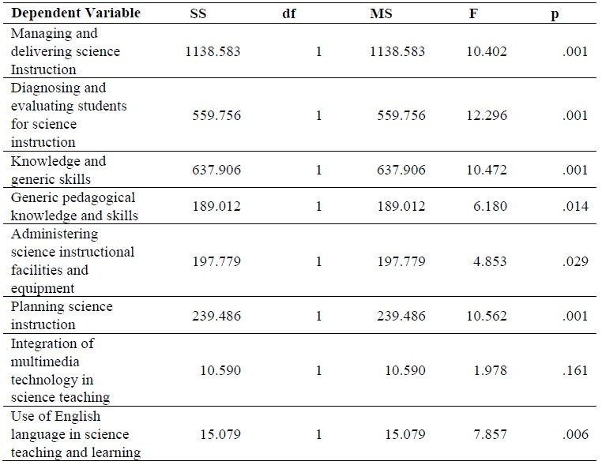
There are also differences between the public knowledge and beliefs of depression among urban and rural Malays in Malaysia, which could also plays a role in determining how well Malays learn English from a psychological perspective. In a survey done by Swami (2011), there is a tendency for urban residents to treat their psychological issues more effectively (Table 3). Although this might not directly reflect in language learning deficiencies of rural residents, it reinforces the lack of awareness and under-development of rural areas in Malaysia.
Table 3. Percentage of participants mentioning each category to describe the best treatments for depression symptoms.
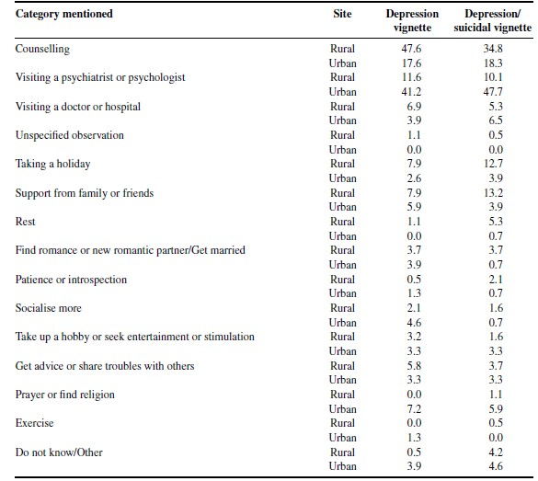
The issue of adolescents’ view on their education could also influence the motivation for rural young people to learn English. While they believed that government is most responsible to help the poor, other parties such as the poor, public and NGO’s should also work together to alleviate poverty. They suggested that these parties can contribute in terms of donation, infrastructural improvement, education, attitudinal change and job opportunities. Respondents acknowledged that hard work and education are important to improve their standard of living. However, education is regarded as a ticket to seek their fortune elsewhere. These results emphasized the need for the Malay adolescents to learn about not being dependent on the government for employment in order to avoid mass urban migration in the near future (Halik and Webley, 2011).
In conclusion, we propose that in order to alleviate and even resolve the rural and urban discrepancies in English language learning, education practitioners could utilize the findings in these studies and start by filling in the gap in aspects like popularizing ICT facilities in rural areas, fulfilling the perceived needs of rural instructors, as well as publicizing knowledge and beliefs to alleviate depression symptoms, etc. These should all be employed as possible strategies in terms of enhancing English education in rural areas, since there has been greater concern on the English literacy problem in rural areas. After all, this is a complex issue, with relations to science and technological infrastructure, pedagogical concerns, psychological issues and economical situations, the nature of the problem or rural English education in Malaysia reflects the complexity of second language education in a multilingual setting, where colonization history exists and language policy was more or less not planned in the first place.

References
Ahmad A., Abiddin N., Badusha J., Wai P. (2009). Computer Usage and Schievement among Adults in Rural Area Malaysia. Journal of Social Sciences. Vol 5(1): pp1-8.
Azman, H. (2002). Multilingual Practices in Rural Malaysia and their impact on English Language Learning in Rural Education. Kirkpatrick, A. (Ed.), Englishes in Asia: Communication, Identity, Power and Education (pp.303-310). Melbourne: Language Australia.
Federation of Malaya. (1956). Report of the Education Review Committee (Razak Report). Federation of Malaya Legislatie Council No 20.
Foo, Bernadette & Richards, Cynthia. (2004). English in Malaysia. RELC Journal,
35/2, pp. 229–240.
Halik M., Webley P. (2011). Adolescents' Understanding of Poverty and the Poor in Rural Malaysia. Journal of Economic Phychology
Idris J., Hasim H., Abidin A. (2011). Digital Inequalities between the Rural and Urban Students in Malaysia. International Journal of Business and Social Science. Vol 2(12): pp201-208.
Liz, Gooch. (2009, July 9). In Malaysia, English Ban Raises Fears for Future. The New York Times. Retrieved from http://www.nytimes.com/
Mahathir, M. (1999). A New Deal for Asia. Petaling Jaya, Selangor: Pelandok Publications.
Saran, K. G. (2002). English language challenges for Malaysia. Kuala Lumpur: UPM Pub.
Swami V., Loo P., Furnham A. (2009). Public Knowledge and Beliefs about Depression among Urban and Rural Malays in Malaysia. International Journal of Social Psychiatry. Vol 56: pp408-496.
Zakaria E., Daud M., Meerah S. (2009). Perceived Needs of Urban and Rural Mathematics Majors Teaching Science in Malaysian Scondary Schools. International Education Studies. Vol 2(2): pp82-89.

